2024 READING OLYMPICS
Tuesday, April 2nd

Bridge Valley Elementary School
2280 Sugar Bottom Road
Furlong, PA 18925

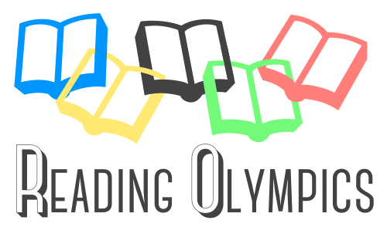

Dear Parents of Olympians,

Just a reminder, your child will be staying after school on Tuesday, April 2nd for the Reading Olympics. We will be making last minute preparations and eating pizza. Again, the bus will be leaving Linden at 5:15 pm and we should be returning to Linden at approximately 8:45 pm.

You and other interested family members are welcome to meet us at Bridge Valley Elementary School. We expect this event to be an enjoyable and rewarding experience for everyone. To ensure a successful evening, we are asking for your cooperation with the guidelines that are listed below.

- This is a heavily attended event. Try to carpool so that traffic jams can be prevented.
- Park within clearly identified parking spaces in the school’s lot. Do not drive or park on the grass.
- The competition begins promptly at 6:00pm. Allow time for parking and finding the assigned classrooms. (listed below)
- Food and beverage (except bottled water) are not allowed at the Olympics. This rule applies to both student participants and spectators.
- Keep in mind that small children will not have the attention span for this academic event and may be happier at home.
- Parents are spectators, not participants. You may not interfere with the questioning process or challenge the moderator’s decisions.
- Student participants and spectators should turn off all cellphones. Video recordings are not permitted.
- If your child is not riding home on the bus, either you or another designated adult must collect him / her from the team leader at the conclusion of the awards ceremony. A note must have been sent in prior to the competition night to the librarian.

We look forward to seeing you and your child at the competition. Whether or not your child’s team accumulates many points, please remember that the students have benefited from a variety of worthwhile reading experiences. Thank you for your support in encouraging your child in preparation for this celebration of reading.

Sincerely,
Debbie Free
Linden Elementary Librarian

Team Name: Da Bookelodeons

Room Assignments:
Round #1:134
Round #2: 134
Round #3: 132

